Case Management System
Dhulekhel Workshop Minute and Outcomes

DHULIKHEL WORK SHOP
Meeting Minute

Date:
Location: DHULIKHEL
Participated By:
S.No | Name | Position | Signature
1 | Suresh Kumar Regmi
2 | Sushil Kumar Pradhan
3 | Iltaaf Hussain Ansari
4 | Jyoti Khanal
5 | Roshan Upadhaya
6 | Ashok Saha
7 | Suman Bhandari
8 | Suraj Shrestha
9 | Raju Shahi
10 | Shyam Sundhar Yadav
CMS 11:40 AM: Iltaf Sir CMS Presentor
- Discussion about the registration
- Banda Sawal
- About Registration Section
- Darpit : Kind of rejection due to some reason
Sadharan Tarikh location – System should be able to provide within all the court of the country.
- Suggestion:
  - Normal:From Any Court
  - Special:Define court only(Bandha Sawal,Baak Pattra)
Note: Soon In future Supremecourt and Applet court will not have tarekh system.Only District court will have.
- Process Flow In District
  - Registration
  - Darta Faant
    - Faaujdari - Dewani
- Courts
  - 7 Pilot court- Dewani Faaujdari in different section
  - 68 General Court –Dewani Faaujdari in same section
- Detail discussion on Mayaad.
  - Mayaad will be issued from Registration Section itself.
  - Mayaad Tamali:
  - Tamildaar Assignment
- Record Taameli Information
- Provision Of Submit , Verification and re-request.

- Taameli conditions:
  - Taameli at Home
  - Taameli in hand
  - Taameli to District personnel in presence of VDC or Gov personnel representative.
  - Person not found(Bepattey)
  - Warent-(Chetipurti)
  - Dewani-Etalayanama
  - Faaujdari-Samawaan
  - Taameli through publication
  - Taameli through mahaniyadibakta (Gov-related)
- Taameli can be also :
  - Through Karaagar (Jail-Custody)
  - Through Embassy too.
- DCM-Differential Case Management-Panel System
  - Differencing cases with respect to nature of the case. (Muddha ko prakriti ko aadhar ma bargi karaan)
  - Differencing cases with respect to level of complication (Priority)
- Can have different Ijalaas-Bench
  - Commercial Bench (Banijaaya)
  - Labour Bench
  - Revenue Bench
- Keep record of when tamali and where?
- Provide mayaad on the basis of the rules in (Mulikiyaan,Neeyam Sangraha)
- First pessi then mayaad
- Conditions for mayaad
  - Mayaad Dinu parne
  - Mayaad Dinu na parne
- Condition for Pessi Tarekh
  - Tarekh Dinu parne
  - Tarekh Dinu na parne
Note : Pramaan mukarrar tarekh (after tarekh is fixed) – Pramaan mukarrar na raakhney ki bhanney kura pani hudaicha hai..
- Two provision of Misil processing
  - Electronic Misil
  - Physical Misil
- System should request to district or other org automatically.
- System should also record the process flow Delivery and receive.
- Warish are of two types
  - General
  - Power
Note: lawyers can also play the role of warish ,but he is not called warish as such.
- Ek choti wakalatnaama darta bhaye pachi baadi le change na garunjel tehi huncha.
- Sthagit ko aayo bhaney, sthagit na hune aadhar haru chahiyo. Criteria puge pachi sthagit hudaina, tesh pachi sthagit huney bhayo bhane matra . Criteria should be within the system – there are some rules that need to be listed.
  - From Appleant side 2 times
  - From Respondent side 2 times
- Sthagit Criteria Yes-No
- After the publication of Daily cause list – Individual Bench
- Before the publication of daily cause list – Chief Justice
- About super user and herna-namilney
- NiSu – Nirnaya Sunawoone
- Discussion about TIPPOT Uthaaune
- Document delete after expiration on basis of its nature
  - Mudda antim bhako miti
- Archiving of decision case with chinuwa no.
- Chinuwa no should assign to the case file right after the decision.
- Which case should go for publication selection method?
  - Tahashil goes to Avilekh
  - Avilekh sends misil
- Decision letter goes to district (Previous Court)
- Jilla lai tahasil na bhayee hunna. Phaisala le ke bhancha?? Phaisala bamojinm chitthi pathaunu parney.
- How should Registration No be?
  - Registration No should be given court wise.
- How should Muddha No be?
  - Unique no of every individual court.
- What is CI, CR???
  - CI-Civil
  - CR-Criminal
- Insisted on Execution Part despite the decision not to include in this project during the SRD approval phase.
- How should diary be maintained?
  - Punarabeden-District-Supreme Court
- Appellant should be able to appeal from any place
- Ardha nyayik mudda haru kasari suru huncha punaravedan ma
- Punarabedhan ma Aanumati –Doraipaau ko thamne karya bidhi wise
  - Suni payeko ko kaagaj – 30-35-70 days
  - Natra bhane taamel bhayeko 30-35-70 days
  - Nakkal liyare ho ki
  - Jariwana bujhayeko miti
  - Samchiiptha aantargaat –With different – different pratiuttar.
  - Malpoot bata aayeko punerabedhan pattra
- In Gov Case 130 days... from hearing date or from tamale date.
- Punerabedhan from where and at what condition.
  - After registered in district court , decided.
  - From case decided court.
  - By self presence too.
  - From Punaravedan registered court
  - From jail(Custdy)
  - If Gov employee then from near punarabedan court
  - From Punerunaravedan court itself
- Pratiuttar nalageko case ma punara bedhan paaudaina
- Record of district Pramaan misil received
- Provision of Case Registration from any place but problem of fees collection
- Case cannot be registered if the applicant is black listed .
- Different steps how a lawyer can postpone a case online.
- What lawyer can do?
  - Can receive tarikh on behalf of appellant
  - Appointment – if required on behalf of Appellant and Respondent
  - Give WarishNaama
  - Bahaas Note
  - Pessi Postpone
    - If BAR representative sends a mail saying that a lawyer could not attend due to some program then case postpones.
- Bahaas note can be sent online
- Because of programs at BAR, lawyers can postpone their case.
- Mediation in presence of mediator.
- Verification of mediation should be in presence of bench officer.
- After Mediation case is closed.
- Multavi (suspend) – Stay- Case Suspend for some time due to
  - Dewani (example given was Nagarikta vs. Ansha) 12 no. bhanney cha(dewani prakriti ko)… 192 no. bhanney… 10 no. bhanney… so and so…. Kun mudda le garda multavi bhako cha…
  - Chori ko list pani 5-6 prakaar ka chann
  - Chori ko 10 no-2 years or 1 years
  - Warrant issue 192-190 6-months
- Multavi (suspend) due to which case and why?
- Kun kun baadi pratibaadi bhaka misil haru chan.. herna milnu paryo.
- Case process checking verivication.
- System should provide Misil list
- System should maintain Misil inventory
- System should Show Punarabedan tamali date for all litigants

4:15 PM – Jyoti Khanal PMS presentor

- Deepak started with the introduction to PMS and the difference between the existing system @ SC and the one that is being developed.
- Office Automation and PMS must linked.
- Karmachari sanket no. is required, karmachari sanchai kosh, bima kosh no., NLK no. and many more
- Niyukti bhaye pachi court le karmachari sanket no. issue garnu parcha
- Equivalent degree be listed there
- Where posted? When to when?
- Saruwa nirnaya, rawana miti, haajir bhako mithi (joined date)
- Reward
- Attendance

Use Case Diagrams
and
Use Case Description
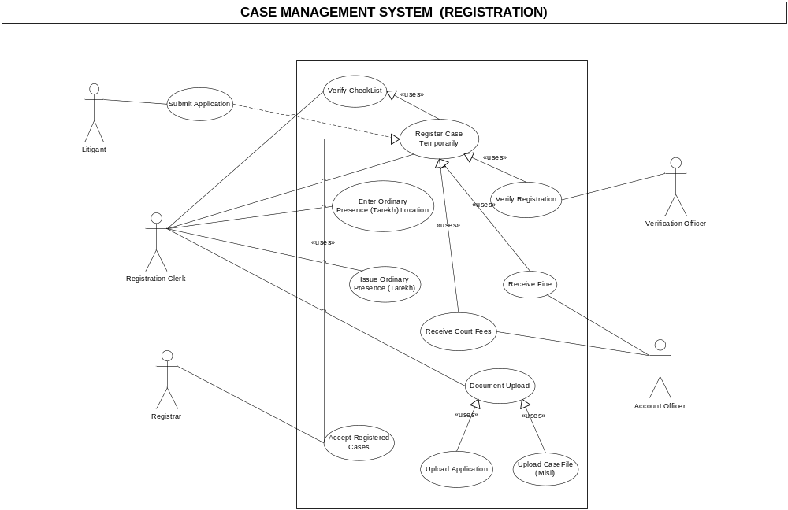

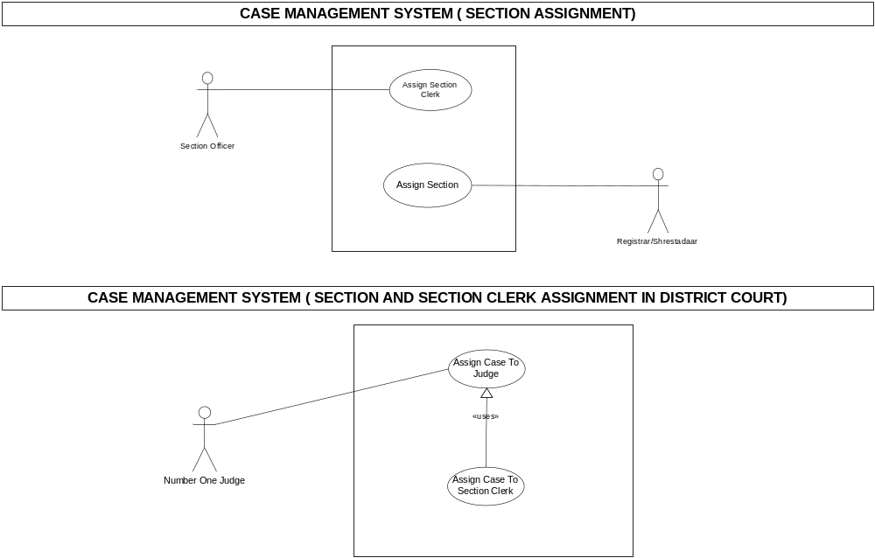

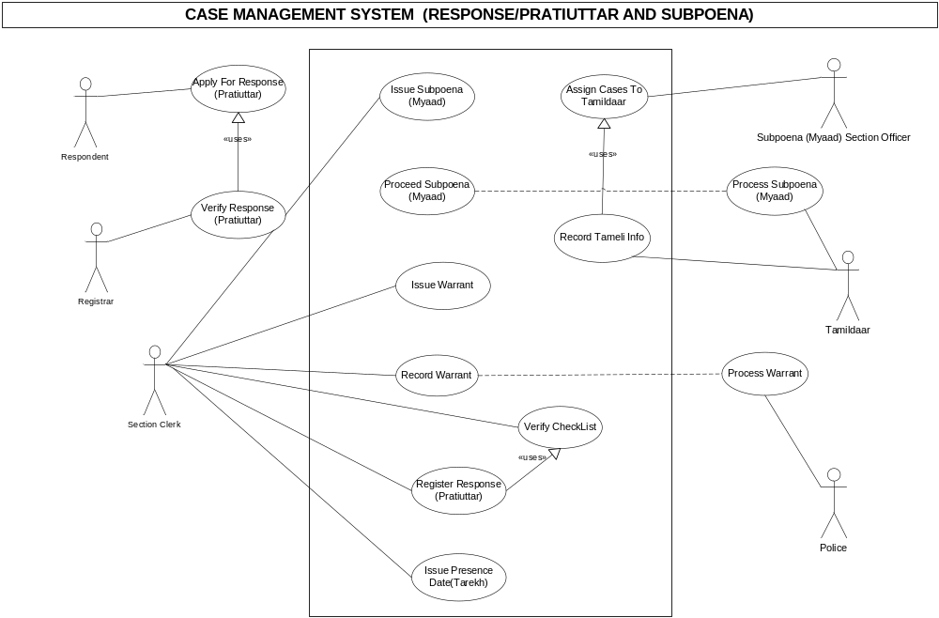

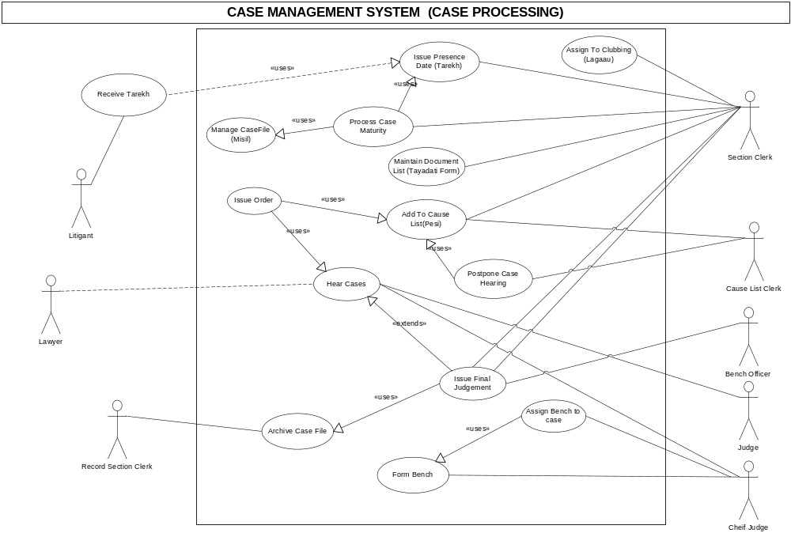

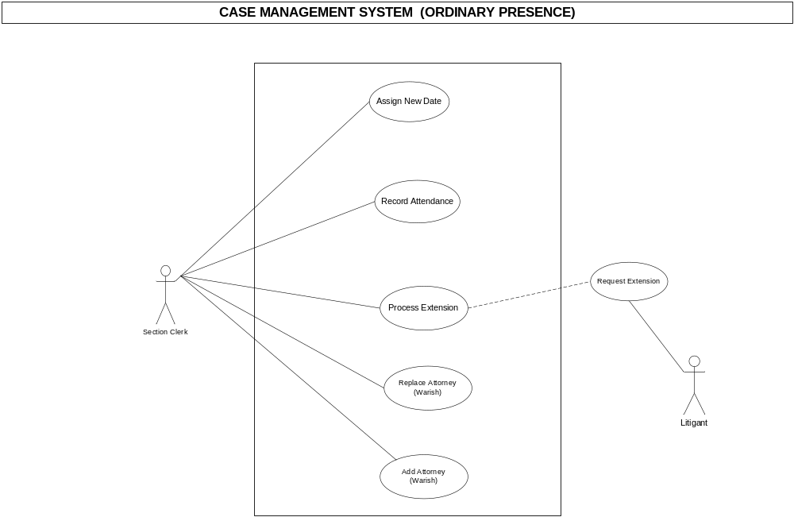

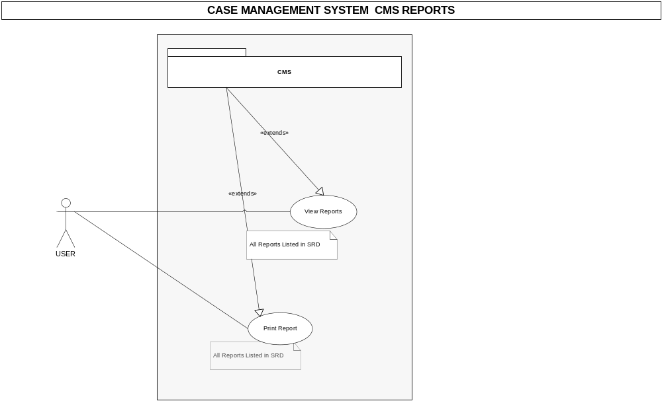

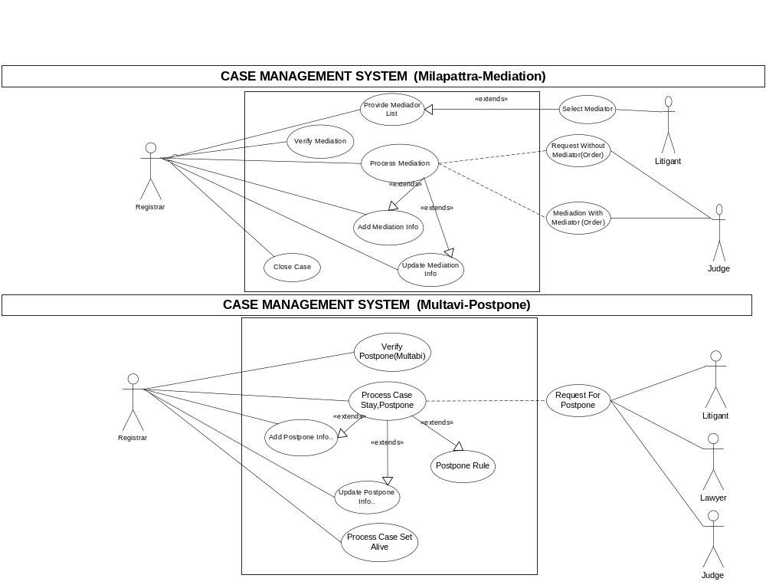
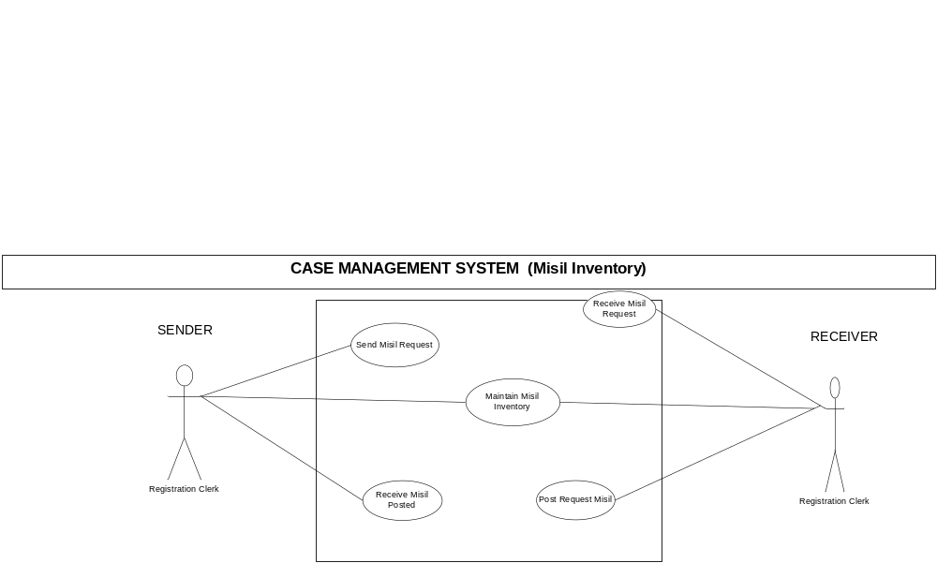
Use Case Description
Registration Process
Actor | Use case | Relationship
Petitioner | Submit Application | Association: The Petitioner will make use of the functionality of this use case. This implies that the Petitioner will apply for registration of case.
Registrar | Check Eligibility For Registration | Association: The Registrar is associated with the use of this use case which uses Submit Application as its input and provides information to Register Case.
Registration Clerk | Register Case | Registration Clerk relationship to this use case is implied through the extend relationship with Register Temporary Cases and Verify Registration use cases. The condition under which the use case is executed is documented under the base use case: Register Case
Registration Clerk | Register Temporary Cases | The Registration Clerk is associated with the use of this use case which is further extended to Register Case use case.
Verification Officer | Verify Registration | The receive fine use caseprovides information to this use case and as such is associated to the use case: Register Case. The extended relationship to Register Temporary Cases implies that the case management system is referenced by these uses cases. Verify Registration use case uses Receive Court Fees and Receive Fine use cases for its executing
Account Officer | Receive Fine | Account officer uses these use case in order to finalize the verification process which is implied through the uses relationship.
Account Officer | Receive Court Fees
Registration Clerk | Enter Ordinary Presence (Tarekh) Location | Association - The Registration Clerk is associated with the use of this use case which implies that Registration Clerk is responsible to enter the Ordinary Presence location.
Registration Clerk | Issue Ordinary Presence (Tarekh) | Association -The Registration Clerk is associated with the use of this use case.
Registration Clerk | Document Upload | Association -The Registration Clerk is associated with the use of this use case. Document Upload can use Upload Application and Upload CaseFile (Misil) use case.

Section Assignment
Actor | Use case | Relationship
Registrar | Assign Section | Association: The Registrar will make use of the functionality of this use case. This implies that the Registrar will assign for section.
Section Clerk | Assign Section Clerk | Association: The Section Clerk will make use of the functionality of this use case. This implies that the Section Clerk will Assign Section Clerk.

Response(Pratiuttar)
Actor | Use case | Relationship
Respondent | Apply For Response (Pratiuttar) | External Association: The Respondent will make use of the functionality of this use case. This implies that the Respondent will Apply For Response (Pratiuttar) manual.
Registrar | Verify Response (Pratiuttar) | External Association: The Registrar will make use of the functionality of this use case. This implies that the Registrar will Verify Response (Pratiuttar) manual.
Section Clerk | Issue Subpoena (Myaad) | Association: The Section Clerk will make use of the functionality of this use case. This implies that the Section Clerk will Issue Subpoena (Myaad).
Section Clerk | Record Subpoena | Association: The Section Clerk will make use of the functionality of this use case. This implies that the Section Clerk will Record Subpoena.
Section Clerk | Issue Warrant | Association: The Section Clerk will make use of the functionality of this use case. This implies that the Section Clerk will Issue Warrant.
Section Clerk | Record Warrant | Association: The Section Clerk will make use of the functionality of this use case. This implies that the Section Clerk will Record Warrant.
Section Clerk | Register Response (Pratiuttar) | Association: The Section Clerk will Register Response (Pratiuttar).
Section Clerk | Issue Presence Date(Tarekh) | Association: The Section Clerk will make use of the functionality of this use case. This implies that the Section Clerk will Issue Subpoena (Myaad).
Tamildaar | Process Subpoena (Myaad) | External Association: Tamildaar will make use of the functionality of this use case. This implies that the Tamildaar will Process Subpoena (Myaad) manual.
Police | Process Warrant | External Association: The Police will make use of the functionality of this use case. This implies that the Police will Process Warrant manual.
Case Processing
Actor | Use case | Relationship
Section Clerk | Asign to Lagaau (Clubbing) | Association: The Section Clerk will make use of the functionality of this use case. This implies that the Section Clerk will Asign to Lagaau (Clubbing).
Section Clerk | Issue Presence Date (Tarekh) | Association: The Section Clerk will make use of the functionality of this use case. This implies that the Section Clerk Issue Presence Date (Tarekh).
Section Clerk | Process Case Maturity | Association: The Section Clerk will make use of the functionality of this use case. This implies that the Section Clerk will Process Case Maturity.
Section Clerk | Maintain Document List (Tayadati Form) | Association: The Section Clerk will make use of the functionality of this use case. This implies that the Section Clerk will Maintain Document List (Tayadati Form).
Section Clerk | Add To Cause List(Pesi) | Association: The Section Clerk will make use of the functionality of this use case. This implies that the Section Clerk will Add To Cause List(Pesi).
Section Clerk | Postpone Case Hearing | Association: The Section Clerk will make use of the functionality of this use case. This implies that the Section Clerk will Postpone Case Hearing.
Section Clerk | Issue Order | Association: The Section Clerk will make use of the functionality of this use case. This implies that the Section Clerk will Issue Order.
Section Clerk | Issue Final Judgement | Association: The Section Clerk will make use of the functionality of this use case. This implies that the Section Clerk will Issue Final Judgement.
Cause List Clerk | Add To Cause List(Pesi) | Association: The Cause List Clerk will make use of the functionality of this use case. This implies that the Cause List Clerk will Add To Cause List(Pesi).
Cause List Clerk | Postpone Case Hearing | Association: The Cause List Clerk will make use of the functionality of this use case. This implies that the Cause List Clerk will Postpone Case Hearing.
Bench Officer | Issue Final Judgement | Association: The Bench Officer will make use of the functionality of this use case. This implies that the Bench Officer will Issue Final Judgement.
Judge | Hear Cases | Association: The Judge will make use of the functionality of this use case. This implies that the Judge will Hear Cases.
Cheif Judge | Form Bench | Association: The Cheif Judge will make use of the functionality of this use case. This implies that the Cheif Judge will Form Bench.
 | Assign Bench to case | Association: The Cheif Judge will make use of the functionality of this use case. This implies that the Cheif Judge will Assign Bench to case.
 | Hear Cases | Association: The Cheif Judge will make use of the functionality of this use case. This implies that the Cheif Judge will Hear Cases.
Record Section Clerk | Archive Case File | Association: The Record Section Clerk will make use of the functionality of this use case. This implies that the Record Section Clerk will Archive Case.
Lawyer | Hear Cases | External Association: The Lawyer will make use of the functionality of this use case. This implies that the Lawyer will Hear Cases manual.
Petitioner | Receive Tarekh | External Association: The Petitioner will make use of the functionality of this use case. This implies that the Petitioner will Receive Tarekh manual.

(Ordinary Presence)
Actor | Use case | Relationship
Section Clerk | Assign New Date | Association: The Section Clerk will make use of the functionality of this use case. This implies that the Section Clerk will Assign New Date (Ordinary Preasence).
Section Clerk | Record Attendance | Association: The Section Clerk will make use of the functionality of this use case. This implies that the Section Clerk will Record Attendance.
Section Clerk | Process Extension | Association: The Section Clerk will make use of the functionality of this use case. This implies that the Section Clerk will Process Extension .
Section Clerk | Process Subpoena (Myaad) | Association: The Section Clerk will make use of the functionality of this use case. This implies that the Section Clerk will Process Subpoena (Myaad).
Section Clerk | Add Attorney (Warish) | External Association: Tamildaar will make use of the functionality of this use case. This implies that the Tamildaar will Add Attorney (Warish).
Petitioner | Request Extension | External Association: The Police will make use of the functionality of this use case. This implies that the Police will Request Extension.

List of Reports

